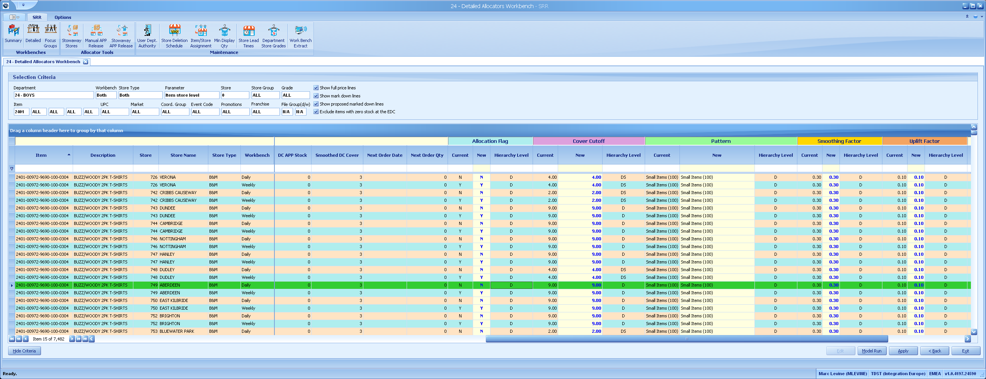

**The Grid**

All the grids in SRR offer a subset of the functionality shown here. The Group By Box, Row Indicators, Column Headers are available in all.

**Column Header Options**

**Auto-Filter**: Right-click to enable/hide the auto filter row. Enter a value into any of the fields to filter the grid by that value.

**Clear a filter**: Click the ‘X’ in the bottom left hand corner of the grid (not shown here).

**Filter Editor:** This allows you to construct complex filtering expressions

**Filtering**: Click the filter icon in the top right corner of the column header to filter the contents of the grid. You can apply multiple filters.

**Grouping**: Drag a column header to the Group By box to group by that column. You can group by multiple columns.  
**Move a column**: Click and drag a column to a new position.

**Remove a column**: Click and drag the column off the grid to remove it.

**Restore a column**: Right-click and select Column Chooser. Then drag columns back onto the grid.

**Sorting**: Click the column header to sort the grid by that column. Once for A-Z, again for Z-A. Right-click and select **Clear Sorting** to restore the grid to its default sort sequence.

**Row Options**

**Level Drilling**: Right-click on a row to drill up or down a level

**Show All**: Show all rows for the selected level

**Refresh**: Refresh the grid, any changes that have been made by you will be lost

**Refresh & Rebuild**: As above but reset the grid layout to the factory design.

**Copy**: Copy one or more rows to the clipboard. They can then be pasted into Word or Excel.

**Export to Excel**: Export all the rows in the grid to an Excel 2007 compatible file (.xlsx). The export respects the current filter, grouping and sorting settings.

**Status Bar**

Left-click here for options

**Row Options**

Right-click here for row options

**Row Indicators**

**Group by box**

Drag a column here to group by it.

**Column Headers**

Right-click here for grid/column options

**Auto filter row**

Enter values here to filter the grid

;

**Status Bar**

Left-click the Environment section (i.e. TDST (Integration Europe) for details about the current environment and data connection.

**Group By**

The grid allows you to group rows by any number of columns. For example you may want to group by Workbench and Store Type. This will collapse the grid down to four rows. Clicking a row indicator will expand the group section.